ICOS
Atmospheric Thematic Center

ICOS Atmospheric Station Specifications

Edited by O. Laurent

Version 1
June 2014
Contents

Introduction 5
1. Rationale and Objectives 6
1.1. General objectives 6
1.2. Data quality objectives 6
1.2.1. Data quality 6
1.2.2. Data compatibility 6
1.3. Network design 7
1.4. ICOS standardized network 8
2. Measurement setup 9
2.1. Station requirement 9
2.1.1. Station location 9
2.1.2. Station setup 10
2.2. Equipment requirements and selection 11
2.2.1. Continuous gas analyzer 11
2.2.1.1. ICOS requirement 11
2.2.1.2. Instrument selection meeting requirements 12
2.2.2. Meteorological sensor 13
2.2.2.1. Wind sensors 15
2.2.2.2. Temperature sensors 16
2.2.2.3. Relative humidity sensors 17
2.2.2.4. Barometric pressure sensors 18
2.2.2.5. Integrated weather station 19
2.2.3. Planetary boundary layer height retrieval instrument 20
2.2.4. Flask sampling 20
2.2.5. Radiocarbon (¹⁴C) sampler 21
2.2.6. Radon monitor 22
2.2.7. Eddy flux measurement 22
2.3. Equipment integration 22
2.3.1. Continuous gas analyzer 22
2.3.2. Meteorological sensors 23
2.3.3. Planetary boundary layer height retrieval instrument 24
2.3.4. Flask sampling 25
2.3.5. Radiocarbon sampler 25
2.3.6. Radon monitor 25
2.3.7. Shelter and tower setup requirement/recommendation 25
2.4. Air Sampling design 26
2.4.1. Continuous measurement 26
2.4.2. Periodical sampling 30
2.5. Maintenance 30
3. Measurement protocol 31
3.1. Flask sampling strategy 31
3.2. Radiocarbon sampling strategy 31
3.3. Continuous gas sampling strategy 31
3.4. Planetary boundary layer height profile strategy 32
4. Calibration, standards 32
4.1. Continuous gas analyzer 32
4.1.1. Calibration protocol 32
4.1.2. Calibration equipment 33
4.1.3. Standard production and calibration 34
4.2. Other instruments 35
4.2.1. Meteorological sensors 35
4.2.2. Radon monitor 35
4.2.3. Planetary boundary layer height retrieval instrument 35
4.2.4. Eddy flux instrument 36
4.3. Central Analytical Laboratory services 36
5. Data management 38
5.1. Overview 38
5.2. Metadata 38
5.3. Data processing and archiving 39
5.4. Additional station metadata and station ancillary data 40
5.5. Data quality control 40
5.6. Data revision 43
6. Quality management 44
6.1. Quality management overview 44
6.2. Quality management system targeted for the ICOS atmospheric network 45
6.2.1. Quality assurance 45
6.2.2. Quality control 45
6.2.3. Quality audit 46
6.3. Requirements for a comprehensive quality control strategy 46
6.4. Quality control strategy for the ICOS atmospheric network 47
6.5. Measurement uncertainties 48
7. Outlook 49
8. References 50
8.1. Abbreviations and acronyms 50
8.2. Terms and definitions 51
8.3. Bibliography 52
8.4. List of contributors 53

Introduction
ICOS (Integrated Carbon Observation System) has the main mission to provide the long-term observations required to understand the present state and predict future behavior of the global carbon cycle and greenhouse gas emissions.

ICOS is a distributed research infrastructure comprising three coordinated, complementary operational observation networks: atmospheric observatories of concentrations of CO₂, CH₄, N₂O and other greenhouse gases (GHG’s), terrestrial flux tower sites to measure the ecosystem exchange of CO₂, water vapour and energy, oceanographic observation platforms including volunteer ships monitoring air-sea fluxes.
Operational monitoring by these networks relies on several central facilities:
an Atmospheric Thematic Center (ATC) for data processing, quality management and Research and Development (R&D),
an Ecosystem Thematic Center (ETC) for data processing and R&D,
an Ocean Thematic Center (OTC),
a Central Analytical Laboratory (CAL) for the preparation of calibration material and flask sample analysis,
Additionally, a data portal (Carbon portal) will provide easy dissemination of and access to ICOS data and complementary products.

This document describes the standard recommended ICOS specifications for atmospheric stations which typically consist of a set of integrated analyzers that reside in a shelter with an air intake system that collects air on a mast. The document groups the main atmospheric specification into: measurement set up (chap. 2), measurement protocols (chap. 3), calibration and standards (chap. 4), data management (chap. 5) and quality management (chap. 6). Drafting of this document was initiated by the specific working groups constituted in 2012 during the preparatory phase of ICOS. Later on it has been discussed at the ICOS atmospheric workshops (during the preparatory phase) and the atmospheric Monitoring Station Assembly (MSA) (during the ICOS transition phase). Once ICOS is operational, i.e. when the ICOS European Research Infrastructure Consortium (ERIC) is established, the MSA will be organized regularly to mainly review, among other things, the stations performance over the past year and discuss on the recent development and instrument evaluation.

Revisions and extensions of this document are expected on a yearly basis as the outcome of the annual ICOS atmospheric MSA.
The latest version is always to be found at the ATC website (https://icos-atc.lsce.ipsl.fr).

The writing of this document has been coordinated by Laurent O. from the ICOS ATC with the contribution from many expert atmospheric scientists (see Chap. 8.4, List of contributors).

- Rationale and Objectives

  - General objectives

In constructing ICOS, the community evolves from a situation where GHG atmospheric measurements were done by more than fifteen laboratories over Europe with their own procedures, using scientific project funding, to a situation where procedures are harmonized and funding is better secured on the long term thanks to the establishment of a dedicated international legal structure: the ICOS ERIC whose members are committed European countries. High precision, long term, compatibility and traceability are key aspects of ICOS atmospheric measurement. The high precision is needed to correctly capture the atmospheric signal which is smoothed out via atmospheric transport. This of course depends somewhat on the time and geographical extent of the study. But it remains that we can only do measurement once in time so that the best precision available at a given time is to be favored. This ensures that the best possible measurements are available for future reference. Maintaining high quality measurement over the long term is a challenge but a necessity for the global carbon cycle study where processes take place at various scales. These processes are especially important for long time scales in terms of climate forcing. Data quality is critical to the success of ICOS. Monitoring stations are organized by national networks which must be standardized to produce data which are compatible and of high quality over a long period of time. Principal investigators (PI) of the measurement sites are responsible to the first order quality control and assurance. This is complemented by a quality assurance plan put into place within the ATC.

  - Data quality objectives
    - Data quality

ICOS targets high quality data which involves high precision measurement and stringent data quality management procedure (including data check/validation).

    - Data compatibility
In order to allow a good interpretation of global or continental scale atmospheric data from different stations and networks, essential for instance for atmospheric transport model inversion studies, the WMO sets the compatibility goal for measurement of the major greenhouse gases and related tracers in the GAW report n° 206. These WMO recommendations, updated every two years by a panel of international experts, are summarized in the following table (cf. Table 1). ICOS targets the same compatibility goal within its own monitoring network and with other international networks, however over an extended concentration range (cf. 2.2.1.1).

Component Compatibility goal range in the unpolluted troposphere
CO₂ ± 0.1 ppm (± 0.05 ppm in the southern hemisphere) 360 … 430 ppm
δ¹³C-CO₂ ± 0.01 ‰ -7.5 … -9 ‰ vs. VPDB
δ¹⁸O-CO₂ ± 0.05 ‰ -2 … +2‰ vs. VPDB
δ¹³C-CH₄ ± 0.02 ‰ -80 … -20 ‰ vs. VPDB
δD-CH₄ ± 1 ‰ -400 … +0 ‰ vs. VSMOW
Δ¹⁴C-CO₂ ± 1 ‰ 0 … 70‰
O₂/N₂ ± 2 per meg -250 … -550 per meg
CH₄ ± 2 ppb 1700 … 2100 ppb
CO ± 2 ppb 30 … 300 ppb
N₂O ± 0.1 ppb 320 … 335 ppb
H₂ ± 2 ppb 450 … 600 ppb
SF₆ ± 0.02 ppt 6 … 10 ppt
Table 1 : WMO recommendation for Compatibility of measurements of greenhouse gases and related tracers (GAW Report N° 206)

  - Network design

In order to achieve the main objective of the atmospheric network, i.e. providing maximum constraints for surface-atmosphere exchange fluxes, the ICOS atmospheric network needs to be carefully designed in terms of station locations. When atmospheric station data are used in inverse transport modelling (or data assimilation) to retrieve regional scale GHG budgets, the main aim is to reduce the uncertainty of the surface-atmosphere flux for targeted spatial and temporal scale, e.g. annually integrated fluxes at national scales. The resulting uncertainty is a combination of two terms, one of which depends on the a priori uncertainty in fluxes (prior knowledge), while the other depends on the uncertainty of the measurements (observational constraint), which also includes uncertainty associated with representing the observations in atmospheric transport models. These representation errors are associated with errors in advection (winds), errors in modelled vertical mixing (mixing height, parameterized convection), and unresolved or imperfectly modelled spatial patterns in fluxes; overall they can be larger than the uncertainty of the measurement itself as targeted within ICOS and thus need to be considered. The prior uncertainty in fluxes is reduced when applying inversions, but the uncertainty reduction critically depends on (a) the sensitivity of the observations to the fluxes (footprints), and on (b) the spatial and temporal correlations of the prior uncertainty matrix. Very long correlation scales imply that a few observations are sufficient to constrain the fluxes, while short correlation scales result in uncertainty reduction only in regions directly “seen” by the network, i.e. the footprint region.
A network development task force has been formed within the ICOS preparatory phase to provide a network design recommendation for synergetic and optimal deployment of stations in Europe. Their interim report provides details on a network design assessment, which involved multi-transport model footprint simulations for hypothetical networks with a high station density. Without a complete propagation of the uncertainties mentioned above, a number of basic recommendations were given that are summarized in the following sections.
Within the new ICOS-INWIRE project (http://www.icos-inwire.lsce.ipsl.fr/) a more complete coordinated network design study over Europe with mesoscale models and based on uncertainty reduction is funded, and the results will be available within 2014 to update this document. Initial results of network design studies are the basis for the recommendations on stations location detailed in Section 2.1.1.

  - ICOS standardized network

In order to get a homogeneous dataset, ICOS aims to standardize the equipment, measurement protocol and the data processing. This is an important aspect for quality assurance but is however not sufficient. Indeed, in order to reduce the risk of a systematic bias within its standardized network, additional periodic measurements with different and independent techniques will be performed. This includes a quality control travelling instrument (e.g. Fourier Transform Infrared (FTIR) analyzer as proposed by Hammer et al., 2012) and/or flask sampling, where flasks are analyzed in a central laboratory with independent technique (e.g. Gas Chromatography). Moreover ICOS will be involved in international intercomparison programs (ICP) to assure the data compatibility with the other international networks such as the WMO GAW. This includes the participation to the WMO round robin ICP and stations collocated with other networks so called super-sites. (e.g. AGAGE, NOAA).

- Measurement setup
  - Station requirement
    - Station location

Based on the initial network design assessment provided by the network development task force, and following from the fact that footprints associated with atmospheric stations are relatively local (on the order of 100 km), the main recommendation is to ensure a homogeneous network that avoids larger spatial gaps. In order to improve the estimate of GHG fluxes over land which display much larger variation than over sea, the majority of the stations should be “continental stations” (see definitions below), while only a small number of stations should be located near the western coast (“coastal station”) to quantify inflow, and a small number of stations should be placed on mountain tops (“mountain station”) as they are more difficult to represent in transport models and in case of high mountains are less directly exposed to air-masses carrying strong surface flux signals from the European continent.
Definition of the 3 station types within the ICOS Network:
- Continental station: a station targeting predominantly continental air-masses.
Example: Trainou (TRN, France) 47.96470°N 2.11250°E
- Coastal station: a station targeting predominantly marine air-masses.
Example: Mace-Head (MHD, Ireland) 53.32583°N 9.89944°W
- Mountain station: a station targeting predominantly free tropospheric air (during night).
Example: Jungfraujoch (JFJ, Switzerland) 46.54749°N 7.98509°E

It should be noted that urban stations which may be deployed in the coming years are not part of the ICOS network (neither Class 1 nor Class 2 ICOS atmospheric stations).

Station location recommendations:
- Nominal distance between stations: ≃ 300 km
- Minimum distance between stations: ≃ 50 km
- Avoid complex terrain where possible
- Avoid short distance (usually less than 40 km) from strong anthropogenic sources (e.g. city) especially if located upstream of the prevailing wind. This is to ensure that observations can be represented in atmospheric transport models with spatial resolution of around of 10-20 km.
- No more than 10% of the total network as mountain stations (free troposphere) for the whole ICOS network

In addition to these recommendations, the ICOS Atmospheric station location should take into account the logistic and economic constraints by considering the existing infrastructure.
A list of existing tall towers (elaborated by the ICOS network design task force) in Europe is available on the ICOS forum (https://icos-atc.lsce.ipsl.fr/forum/). Moreover, the so called “historic stations” should be considered as an existing backbone for the network construction.

    - Station setup

The ICOS defines two classes of atmospheric station (AS) according to the set of parameters measured. The Class 1 AS manages a large range of mandatory measurements, whereas Class 2 AS operates only a subset of these. The mandatory parameters for each category are resumed in the Table 2.

Requirements for data quality and compatibility are the same for ICOS class 1 and class 2 stations.

Category | Gases, continuous | Gases, periodical | Meteorology, continuous | Eddy Fluxes
Class 1  Mandatory parameters | - CO₂, CH₄, CO : at each sampling height | - CO₂, CH₄, N₂O, SF₆, CO, H₂,¹³C and ¹⁸O in CO₂: weekly sampled at highest sampling height  - ¹⁴C (radiocarbon integrated samples): at highest sampling height | - Air temperature, relative humidity, wind direction, wind speed: at highest and lowest sampling height*  - Atmospheric Pressure  - Planetary Boundary Layer Height**
Class 2  Mandatory parameters | - CO₂, CH₄ : at each sampling height |  | - Air temperature, relative humidity, wind direction, wind speed: at highest and lowest sampling height*  - Atmospheric Pressure
Recommended parameters*** | - ²²²Rn, N₂O, O₂/N₂ ratio  - CO for Class 2 stations | - CH₄ stable isotopes, O₂/N₂ ratio for Class 1 stations: weekly sampled at highest sampling height |  | - CO₂ : at one sampling height
* Atmospheric temperature and relative humidity recommended at all sampling heights
** Only required for continental stations.
*** Recommended for its scientific value but support from ATC in terms of protocols, data base, spare analyzer will not be ensured as long as the parameters are not mandatory.

Table 2: ICOS AS parameter set

Regarding the sampling heights for the continuous gas analysis, ICOS specifies the following requirements for the three station types:
- Continental stations, targeting mixed layer air over land:
  - Top level: >=100 m (exception: locations where nocturnal stable boundary layer can frequently, at least 30%, be captured by a shorter tower)
  - Other mandatory levels: 10m (above vegetation), 50m (nominal; 40-70 m accepted), (100m, 200m, 300m for taller towers)
For instance, a tower with 300 m height should have sampling levels at about 10, 50, 100, 200, 300 m.
- Coastal stations, targeting marine air masses
  - Top level: sufficiently high to avoid contamination e.g. by local sources
  - No other mandatory levels
- Mountain stations, targeting free troposphere
  - Top level: sufficiently high to avoid contamination e.g. by local sources
  - No other mandatory levels

  - Equipment requirements and selection
    - Continuous gas analyzer
      - ICOS requirement

In order to meet the WMO compatibility goal (cf. 1.2.2) within the ICOS network, the continuous gas analyzers deployed must be compliant to the performance requirement specified in the Table 3 below. As ICOS targets the best performance instrument suitable for large operational network, these requirements may be updated regularly according to the user needs and by taking into account the overall improvement of performances expected for new analyzers emerging on the market. The requirements updates must be taken into account for buying new instrument.

Component | Guaranteed Specification Range | Precision¹ | Reproducibility²
 |  | Std. dev. (1-σ);  1’ / 60’ average raw data | Std. dev. (1-σ);  10’ average raw data
CO₂ | 300 - 500 ppm | < 50 ppb / 25 ppb | < 50 ppb
CH₄ | 1500 - 2500 ppb | < 1 ppb / 0.5 ppb | < 0.5 ppb
N2O | 300 – 500 | < 0.1 ppb / 0.05 ppb | < 0.1 ppb
CO | 30 - 1000 ppb | < 2 ppb / 1 ppb | < 1 ppb

Test conditions : dry air; room temperature : 20 °C ± 2°C; room pressure: atmospheric pressure with a natural variation.

¹ Measuring a gas cylinder (filled with dry natural air) over 25 hours; first hour rejected (stabilization time).
² Measuring alternately a gas cylinder (filled with dry natural air) during 30 minutes and ambient air (not dried) during 270 minutes over 72 hours. Statistics based on the last 10 minute average data of each 30 minute cylinder gas injection (first 20 minutes rejected as stabilization time).

Table 3 : Gas analyzer performance required by ICOS (as of June 2014)

These performance requirements must be guaranteed by the manufacturer (analyzer’s specifications) for the specified concentration range in dry air (cf. Table 3). The performance and robustness for long-term monitoring applications must be demonstrated during long-term (at least one year) field tests performed either by the ATC or associate laboratories.
Moreover, any gas analyzer must be evaluated by the ATC Metrological Lab prior to field deployment to establish the ICOS compliance certificate. The evaluation is carried out according to the ATC standard protocol (cf. the instrument evaluation report available on ICOS forum: https://icos-atc.lsce.ipsl.fr/forum/). The test duration is estimated to be one month. When buying a new gas analyzer, the station PI must contact ATC to schedule the evaluation date with 3 month anticipation and manage the instrument delivery to ATC. If, for some reason, this evaluation has not been performed at the ATC before deployment (e.g. Instrument already deployed before ATC is operational), the station PI must contact the ATC to schedule a convenient date.
The continuous gas analyzer must require a low on-site maintenance, ideally limited to maintenance of pump (annual) and inlet filters. The instrument should not need any frequent (ideally less than every 5 years) maintenance at the manufacturer’s premises. The after sales service provided by the manufacturer must be reactive and efficient.
In order to limit the running cost and logistic, the instrument should not require any running consumable.

      - Instrument selection meeting requirements

The ICOS ATC Metrological Lab is in charge of evaluation of the continuous gas analyzers available on the market and has made a list of instruments (cf. Table 4) compliant to ICOS requirements (cf. Section 2.2.1.1). This selection is based on the results of lab and field tests discussed during annual ICOS workshops/MSA. The update of this ICOS compliant instrument list will be discussed and validated during the MSA.
ICOS Atmospheric Stations must be equipped with the instruments listed in the Table 4 which measure the mandatory species required by their ICOS station Class (cf. Table 2).
The instrument ICOS status lifetime has been fixed to a minimum of 5 years. Once elapsed, few services such as training and spare parts can be disrupted. However, the data will be always processed by the ATC.

Brand | Model | Species | ICOS Status |  |  |  | Eligibility Condition
 |  |  | CO₂ | CH₄ | CO
PICARRO | G1301 | CO₂/CH₄/H₂O | • | • | -
PICARRO | G2301 | CO₂/CH₄/H₂O | • | • | -
PICARRO | G2401 | CO₂/CH₄/CO/H₂O | • | • | • | With ICOS specifications
LGR | 907-0015 | CO/N₂0/H₂O | - | - | • | Precaution with  ∆ temperature
LGR | 913-0015 (EP) | CO/N₂0/H₂O | - | - | •
• : ICOS Compliant x : Not ICOS Compliant T : Test in Progress - : Not applicable
Table 4: list of continuous gas analyzers selected for ICOS (as of June 2014)

Refer to the ATC’s Qualifying test reports for more detailed information (available on the ATC website).

    - Meteorological sensor
In order to characterize the weather conditions at the ambient air sampling site, ICOS requires monitoring of the following meteorological parameters: wind direction, wind speed, air temperature, relative humidity and barometric pressure. The corresponding ICOS meteorological sensor selection is based on the WMO recommendation specified in the WMO Guide N° 8 (Table 5). However, as ICOS does not aspire to be part of a weather station network, the ICOS requirements on meteorological parameters is not as stringent as the WMO requirements. Indeed, the measurement uncertainty required by WMO is so stringent for certain meteorological variables (i.e. temperature), that adhering to WMO requirements would induce unnecessary investment for the ICOS Atmospheric Stations. Therefore the ICOS measurement uncertainty (1σ on single data) requirements are based on the relaxed constraint of “achievable uncertainty” specified by the WMO.

Variable |  |  | Range ¹ | Resolution² |  |  | Mode of measurement ³ |  | Required measurement uncertainty ⁴ | Sensor time constant ⁵ |  | Output average time ⁶ |  | Achievable uncertainty ⁷
Wind speed |  | 0 to 75m/s |  | 0.5m/s |  | Averaging |  | 0.5m/s [0m/s; 5m/s]  10% [5m/s; 75m/s] |  |  | Distance Constant |  | 2 and 10min |  | 0.5m/s [0m/s; 5m/s]  10% [5m/s; 75m/s]
Wind direction |  |  | 0 to 360° | 1° |  | Averaging |  | 5° |  |  | 1s |  | 2 and 10min |  | 5°
Temperature (Air) |  | -80 to +60°C |  | 0.1°C |  | Instantaneous |  | 0.3K [-80°C; -40°C]  0.1K ]-40°C; +40°C]  0.3K ]+40°C; +60°C] |  |  | 20s |  | 1min |  | 0.2 K
Relative humidity |  | 0 to 100% |  |  | 1% | Instantaneous |  | 1% |  |  | 40s |  | 1min |  | 3%
Barometric pressure | 500 to 1080hPa |  |  |  | 0.1hPa | Instantaneous |  | 0.1hPa |  |  | 20s |  | 1min |  | 0.3 hPa
Table 5: WMO operational measurement uncertainty requirements and instrument performance
(Annex 1.B of WMO-N. 8 -Guide to Meteorological Instruments and Methods of Observation, 7th Ed.)

¹ Common range. Limits depend on local climatological conditions. It refers to the requirement established by the CBS Expert Team on Requirements for Data from Automatic Weather Stations in 2004.
² Most stringent resolution as determined by the Manual on Codes (WMO-No. 306). It refers to the requirement established by the CBS Expert Team on Requirements for Data from Automatic Weather Stations in 2004.
³ Mode of measurement:
Instantaneous: in order to exclude the natural small-scale variability and the noise, an average value cover a period of 1 min is considered as a minimum and most suitable; averages over periods of up to 10 min are acceptable.
Averaging: average values over a fixed period, as specified by the coding requirements.
It refers to the requirement established by the CBS Expert Team on Requirements for Data from Automatic Weather Stations in 2004.
⁴ Recommended measurement uncertainty for general operational use, i.e. of level II data according to FM 12, 13, 14, 15 and its BUFR equivalents. They have been adopted by all eight technical commissions and are applicable for synoptic, aeronautical, agricultural and marine meteorology, hydrology, climatology, etc. These requirements are applicable for both manned and automatic weather stations as defined in the Manual on the Global Observing System (WMO-No. 544). Individual applications may have less stringent requirements. The stated value of required measurement uncertainty represents the uncertainty of the reported value with respect to the true value and indicates the interval in which the true value lies with a stated probability. The recommended probability level is 95 per cent (k=2), which corresponds to the 2 σ level for a normal (Gaussian) distribution of the variable. The assumption that all known corrections are taken into account implies that the errors in reported values will have a mean value (or bias) close to zero. Any residual bias should be small compared with the stated measurement uncertainty requirement. The true value is the value which, under operational conditions, perfectly characterizes the variable to be measured/observed over the representative time interval, area and/or volume required, taking into account sitting and exposure.
It refers to the requirement established by the CBS Expert Team on Requirements for Data from Automatic Weather Stations in 2004.

⁵ It refers to the typical operational performance established by the CIMO Expert Team on Surface Technology and Measurement Techniques in 2004.
⁶ It refers to the typical operational performance established by the CIMO Expert Team on Surface Technology and Measurement Techniques in 2004.
⁷ Achievable measurement uncertainty is based on sensor performance under nominal and recommended exposure that can be achieved in operational practice. It should be regarded as a practical aid to users in defining achievable and affordable requirements. It refers to the typical operational performance established by the CIMO Expert Team on Surface Technology and Measurement Techniques in 2004.

The following sections provide the ICOS requirements and recommendations for each meteorological parameter. The ATC will maintain and update a list of sensors which meet those requirements. Station PIs are invited to contribute to update the list by requesting to ATC the evaluation of unlisted sensors.
The measurement uncertainties given in the following tables are sensor specifications provided by the manufacturer and will not be controlled by the ATC.

      - Wind sensors

For maintenance reasons, ICOS recommends the use of 2D ultrasonic wind sensor instead of the conventional cup and vane or propeller wind sensors. Moreover, the sensor must be adapted to the weather conditions (operational temperature, icing). Thus, the sensor must be heated (with an appropriate power supply) if the station is prone to condition of ice and snow.

ICOS requirements:
- Wind speed measurement uncertainty required by ICOS: 0.5m/s [0m/s; 5m/s]
10% [5m/s; 75m/s]
- Wind direction measurement uncertainty required by ICOS: 5°
- Wind speed range adapted to the site (i.e. mountain)
- Wind speed measurement resolution : 0.5 m/s
- Wind direction measurement resolution: 1°

Brand | Model | Wind speed measurement uncertainty | Wind direction measurement uncertainty | ICOS Status
GILL | WindSonic | ±2% at 12 m/s | ±3º at 12 m/s | ICOS Compliant
GILL | WindSonic M | ±2% at 12 m/s | ±3º at 12 m/s | ICOS Compliant
GILL | WindObserver | ±2% at 12 m/s | ±3º at 12 m/s | ICOS Compliant
GILL | WindObserver 65/70/75 | ±2% at 12 m/s | ±2º at 12 m/s | ICOS Compliant
LUFT | Ventus | ± 2% RMSE(>2m/s) | ± 2° RMSE | ICOS Compliant
THIES | Ultrasonic Compact | ± 2% RMS(>5m/s) | ± 2° | ICOS Compliant
THIES | Ultrasonic 2D | ± 2% RMS(>5m/s) | ± 1° | ICOS Compliant
VAISALA | WMT52 | ±0.3 m/s or ±3% [0m/s; 35m/s]  ±5% [36m/s; 60m/s] | ±3° | ICOS Compliant
VAISALA | WS425 | ± 0.135 m/s or 3% of reading  [0m/s; 65m/s] | ±2° (wind speed > 1 m/s) | ICOS Compliant
YOUNG | 85000 | ± 2% or 0.1 m/s (30 m/s)  ± 3% (70 m/s) | ±2° | ICOS Compliant
Table 6: wind sensors and their assessment for ICOS

      - Temperature sensors

ICOS requirements:
- Temperature measurement uncertainty: 0.2K on the temperature range adapted to the site.
- Temperature range adapted to the site (i.e. mountain)
- Measurement resolution : 0.1°C

Brand | Model | Temperature measurement uncertainty | ICOS Status
CAMPBELL | CS215 PWS | ±0.3°C at 25°C;  ±0.4°C [+5; +40°C]  ±0.9°C [-40°; +70°C] | NOT ICOS Compliant
VAISALA | HMP45 | ±0.5 °C at -40°C  ±0.2 °C at 20°C  ±0.3 °C at +40°C | NOT ICOS Compliant
VAISALA | HMP60 | ±0.6 °C [-40°C; +60°C] | NOT ICOS Compliant
VAISALA | HMP110 | ±0.4 °C [-40°C; 0°C]  ±0.2 °C [0°C; +40°C]  ±0.4 °C [+40°C; +60°C] | NOT ICOS Compliant
VAISALA | HMP155 | ±0.12 °C at 20°C | ICOS Compliant
VAISALA | PTU300 | ±0.4 °C at -40°C  ±0.2 °C at +20°C  ±0.3 °C at +60°C | NOT ICOS Compliant
YOUNG | 41382 | ±0.3 °C at 0°C | NOT ICOS Compliant
ROTRONIC | HC2-S3 | ±0.1 °C at 23°C ±5K | ICOS Compliant
ROTRONIC | MP102H  MP402H | ±0.1 °C at 23°C ±5K | ICOS Compliant
Table 7: temperature sensors and their assessment for ICOS

      - Relative humidity sensors

ICOS requirements:
- Relative humidity measurement uncertainty: 3% on the temperature and relative humidity range adapted to the site.
- Measurement resolution : 1%

Brand | Model | Relative Humidity  measurement uncertainty | ICOS Status
CAMPBELL | CS215 PWS | ±2 %RH [0%; 90%] at 25°C  ±4 %RH [90%; 100%] at 25°C | NOT ICOS Compliant
VAISALA | HMP45 | ±3 %RH [0%; 90%]  ±5 %RH [90%; 100%] | NOT ICOS Compliant
VAISALA | HMP60 | ±3 %RH [0%; 90%]  ±5 %RH [90%; 100%] | NOT ICOS Compliant
VAISALA | HMP110 | ±1.7 %RH [0%; 90%]  ±2.5 %RH [90%; 100%] | ICOS Compliant
VAISALA | HMP155 | ±1 %RH [0%; 90%]  ±1.7 %RH [90%; 100%] | ICOS Compliant
VAISALA | PTU300 | ±1 %RH [0%; 90%]  ±1.7 %RH [90%; 100%] | ICOS Compliant
YOUNG | 41382 | ±2 % at 20°C | ICOS Compliant
ROTRONIC | HC2-S3 | ±0.8 % at 23°C ±5K | ICOS Compliant
ROTRONIC | MP102H  MP402H | ±0.8 % at 23°C ±5K | ICOS Compliant
Table 8: relative humidity sensors and their assessment for ICOS

      - Barometric pressure sensors

ICOS requirements:
- Pressure measurement uncertainty: 0.3 hPa on the pressure range adapted to the site.
- Barometric pressure range adapted to the site (i.e. mountain)
- Measurement resolution : 0.1 hPa

Brand | Model | Barometric pressure  Measurement uncertainty | ICOS Status
CAMPBELL  (SETRA) | CS100  (278) | ±0.5 hPa at 20°C  ±2 hPa (-40 to +60°C) | NOT ICOS Compliant
DRUCK | RPT410V | ±0.5 hPa at 20°C  ±2.5 hPa (-40 to +60°C) | NOT ICOS Compliant
VAISALA | PTB110 | ±0.3 hPa at 20°C | NOT ICOS Compliant
VAISALA | PTB210 | ± 0.15hPa at 20°C | ICOS Compliant
VAISALA | PTU300 | ±0.1 hPa at 20°C | ICOS Compliant
YOUNG | 61302 | ±0.2 hPa at 25°C  ±0.3 hPa (-40 to +60°C) | ICOS Compliant
Table 9: barometric pressure sensors and their assessment for ICOS

      - Integrated weather station

ICOS requirements:
- Wind speed measurement uncertainty required by ICOS: 0.5m/s [0m/s; 5m/s]
10% [5m/s; 75m/s]
- Wind direction measurement uncertainty required by ICOS: 5°
- Wind speed range adapted to the site (i.e. mountain)
- Wind speed measurement resolution : 0.5 m/s
- wind direction measurement resolution: 1°
- Temperature measurement uncertainty: 0.2K on the temperature range adapted to the site.
- Temperature range adapted to the site (i.e. mountain)
- Temperature measurement resolution : 0.1°C
- Relative humidity measurement uncertainty: 3% on the temperature and relative humidity range adapted to the site.
- Relative humidity measurement resolution : 1%
- Pressure measurement uncertainty: 0.3 hPa on the pressure range adapted to the site.
- Barometric pressure range adapted to the site (i.e. mountain)
- Pressure measurement resolution : 0.1 hPa

Brand | Model | Wind speed meas. uncertainty | Wind direction meas. uncertainty | Temperature meas. uncertainty | Relative Humidity meas. uncertainty | Barometric Pressure meas. uncertainty | ICOS Status
GILL | MetPak2 | ±2% at 12 m/s | ±3º  at 12 m/s | ±0.1°C | ±0.8 %RH  at 23°C | ±0.5 hPa | NOT ICOS  Compliant
VAISALA | WXT520 | ±0.3 m/s or ±3% [0m/s; 35m/s]  ±5%  [36m/s; 60m/s] | ±3° | ±0.2°C  [-52°C; -20°C]  ±0.4°C  [-20°C; +40°C]  ±0.7°C  [40°C; +60°C] | ±3 %RH  [0%; 90%]  ±5 %RH [90%; 100%] | ±0.5 hPa  [0°C; +30 °C]  ±1 hPa  [-52°C; +60 °C] | NOT ICOS  Compliant
Table 10: integrated weather stations and their assessment for ICOS

    - Planetary boundary layer height retrieval instrument

The depth of the vertical mixing by turbulence within the planetary boundary layer has a large effect on GHG mixing ratios, but is not well represented by PBL schemes used in transport models. To reduce the impact on inversion results, information on mixing heights can be used. In ICOS, Mixing height (MH) is retrieved from Ceilometer/Lidar backscatter profiles.
During the ICOS preparatory phase, the intercomparaison campaign of MH measuring instruments(Haeffelin et al., Milroy et al., 2011) qualified the Leosphere ALS300 (lidar), Vaisala CL31, Jenoptik CHM15k (ceilometer). Unfortunately these instruments are now discontinued.
The following recommendation is now based on expert knowledge (ICOS-INWIRE, ACTRIS…).
ICOS AS without any local dedicated lidar expertise should rather rely on state of the art ceilometers (more sensitive, with smaller overlap and optimized for mixing layer compared to the first versions of ceilometers tested during the ICOS campaigns). The followings two ceilometers offer similar performance:
- Vaisala CL51 (Ceilometer)
- Jenoptik CHM15k-x (Ceilometer)

Indeed, even if ceilometers are less powerful and have usually a lower signal to noise ratio than lidars, resulting in a lower MH data coverage, ceilometer presents the advantage of low maintenance and robustness fit to operational networks. The instruments are also good value for money for ICOS purposes.
On the other hand, lidar tend to provide better performance, especially in difficult conditions (low aerosols concentration, heavy fog…). Nowadays, they do require specific expertise (aerosols) and trained technical staff for operation. This can be worth the investment for a site that collocates GHG and aerosol measurements (e.g. ICSO-ACTRIS synergies).
The ICOS-INWIRE project will contribute to further define guidelines to choose MH measuring instruments, especially for site with more extreme conditions (eg very low aerosol concentrations).
The ICOS standardization for the MH retrieval within the AS network will benefit from the use of common retrieval algorithm. The development of such algorithm is a dedicated task (task 3.2) of the ICOS-INWIRE project (work in progress).

    - Flask sampling
Measurement of air periodically sampled in flasks at atmospheric station allows additional parameter measurements (SF₆, H₂, CO₂ stable isotopes …) which are not performed by in-situ continuous analyzers and an independent quality control for continuous in-situ measurements (cf. 6.4).
Within the ICOS atmospheric network, the air flasks will be sampled by an automatic flask sampler which will allow automatic sampling during suitable atmospheric conditions (cf. 3.1).
This automatic flask sampler is under further development/construction within the framework of the ICOS-Inwire project.
The periodical air sampling (once a week) must be done with the approved ICOS flask:

2 Liter glass flask from Normag : reference SA-907 with the following mentions:
- tolerances according to construction drawings provided by MPI- Jena
- flame polished glass connectors & o-ring grooves
- freely rotating Kel-F cap on the valve stem

The Normag flask are not equipped with cap which should be buy separately (manufacturer and reference – specifications in progress)

Each station is required to own about 100 flasks in order to prevent facing any logistics issues or CAL congestion. All ICOS flasks samples are to be analyzed by the CAL in Jena, Germany as soon as the CAL will be fully operational.

    - Radiocarbon (¹⁴C) sampler
The atmospheric fraction of the CO₂ radioactive isotope, ¹⁴CO₂, is used as a fossil fuel tracer in order to identify the anthropogenic pollution sources (fossil fuel combustion). Since the carbon in fossil fuels is totally depleted in ¹⁴C, its emission and mixing in the atmosphere causes a depletion of the observed ¹⁴C fraction in atmospheric CO₂.
The currently recommended ICOS sampling method is chemical absorption in NaOH solution.
The ¹⁴CO₂ sampler consists in pumping continuously ambient air over several days through a CO₂ absorbing sodium hydroxide (NaOH) solution. In order to enlarge the NaOH reaction surface, the solution is hold in a rotating glass tube filled with a packed bed of glass Raschig rings. With this method the atmospheric CO₂ is absorbed nearly quantitatively in the NaOH solution.
The sample is then sent to the ICOS CAL-CRL in Germany for analysis.
The station PIs requiring an appropriated integrated ¹⁴CO₂ sampler (at least all the Class 1 ICOS AS) must contact the ICOS CAL-CRL.

The air pumped for analysis should be taken from the highest tower level (in case of multiple sampling height tower).

In addition to the integrated sampling presented above, diurnal and event based sampling campaigns are under study.

Diurnal cycle and event based sampling will be made with the standard flask sampler (cf. 2.2.4) using 3 liter Normag flask reference SA-909 with the following mentions:
- tolerances according to construction drawings provided by MPI- Jena
- flame polished glass connectors & o-ring grooves
- freely rotating Kel-F cap on the valve stem

Diurnal cycle sampling is currently not mandatory for ICOS stations because full ¹⁴C network design and sampling strategy have not yet been finalized.

    - Radon monitor
At the present stage, Radon-222 measurement is not mandatory in ICOS (see Table 2). However, Radon-222 is recognized as a very valuable measurement in particular for trace gas flux estimate.
There are two different radon measurement principles in use at European and global atmospheric stations: (1) Measurement of Radon-222 (²²²Rn) with a two filter system (e.g. ANSTO system) and (2) measurement of ²²²Rn daughters attached to aerosols and accumulated on one filter, and determination of ²²²Rn from its daughter activity assuming a height-dependent disequilibrium factor (e.g. Heidelberg system). Method (1) is advantageous at tall towers to avoid loss of radon daughters in long tubing, however the measurement system is large and it may be difficult to host it at remote stations where space is limited. A radon monitor using method (2) has been developed at UHEI-IUP and improved within ICOS-PP. Extensive tests have also been carried out to quantify the loss of radon daughters in ½ inch Decabon tubing (1300 Synflex tubing) of up to 200m length, in order to develop respective correction functions and use it at ICOS stations. Furthermore, extensive inter- comparison campaigns between the ANSTO and the UHEI system are currently under way (in the frame of InGOS NA3). As these tests have not yet been finalized, a recommendation has not been provided for the type of Radon-222 monitoring system to be used at ICOS stations.

    - Eddy flux measurement

Please refer to ICOS ETC specifications.

  - Equipment integration

    - Continuous gas analyzer

In order to limit the temperature variation around the instruments, it is highly recommended to install them inside a temperature controlled (ideally +/-2°C) room (e.g. air conditioning). The room temperature should be adapted to the site setup and meteorological conditions, neither too low to avoid possible condensation in the tubing in summertime (inside/outside temperature gradient must be limited) nor too high to avoid overheating instrument (reducing Hardware lifetime and instrument temperature regulation performance). A typical room temperature is around 23°C. Moreover, as instruments are mostly sensitive to the quick temperature variation, it should be ideally installed in an enclosed mounting rack to buffer temperature change potentially induced by the air conditioning air flow. This setup limits also the amount of dust particles around this instrument.
The gas analyzer must be associated with an air sampling and distribution system (cf. 2.4.1). This system allows sampling the air at different heights on a tall tower and measuring different gas cylinders. Thus a single instrument can automatically analyze the air at different tower heights and be calibrated according to a specific sequence. It’s important that the analyzers and the sequencer (also called scheduler) which manages the distribution system (valves) are well synchronized with a time server (e.g. GPS or internet NTP server). This secures the identification of the origin of the gas analyzed (which cylinder or which sampling height) with the appropriate time stamp.

    - Meteorological sensors

The sensor installation should be as compliant as possible to the WMO recommendation resumed in the WMO Guide N°8.
The temperature and relative humidity sensor must be installed in a radiation shield (e.g. a Campbell MET 21 or a Vaisala DTR13) in order to provide a protection from the scattered as well as direct solar radiation and rain. The radiation shield must be well ventilated. However, in order to avoid failure and maintenance, ICOS recommends using a naturally ventilated large radiation shield which offers sufficient performance for ICOS purpose, instead of forced ventilated radiation shield.
Concerning the air pressure measurement, the wind can induce dynamic pressure fluctuations on static pressure (Liu, 1989). In order to minimize this issue, ICOS recommends using the barometer with an appropriate pressure port (e.g. Young 61002).
The wind sensor must be kept away from local obstruction (e.g. building, tree, interface box) as much as possible. The WMO recommends installing the wind sensor at a minimum distance of 10 times the obstacle height.

Sensor sitting (height above the ground level):

For Atmospheric Stations with a single air sampling height, the wind sensor must be collocated with air inlet for continuous gas analysis if the location is suitable regarding to the WMO recommendations. If the air inlet location is in the vicinity of a substantial obstruction, the wind sensor must be installed on an independent mast at 10m above the ground level located in a more suitable environment. The temperature and relative humidity sensors must be installed in an appropriate shield at least at 2m from any important surface (e.g. ground, shelter). Moreover, the temperature and humidity sensor shield as well as the barometer pressure port must be freely exposed to the wind.

In the specific case of sites with several sampling heights (tall tower), the Atmospheric Station must be equipped at least with a set of a wind sensor (speed and direction), a temperature and relative humidity sensors at the highest and lowest sampling heights on the tower. Moreover, ICOS recommends to install as well temperature and relative humidity sensors at the intermediate sampling height(s) if exists. ICOS requires using a single barometer which can be equally installed at whichever height. However, for maintenance convenience, ICOS recommends setting up the barometer to an easy access location (e.g. lowest sampling height or ground level).
In order to minimize the wind shadow effect induced by the tower structure, the wind sensor must be installed facing the prevailing wind at a significant distance from the tower by using a dedicated arm. The arm length depends on the type of tower construction. For instance, for a light framework steel tower, the wind sensor should be at least at 3 meters away from the tower structure. For a massive concrete tower, the arm should be longer, as long as possible (best effort). An alternative option consists in duplicating the wind sensors (opposite sides) on each sampling heights.
These wind shadow considerations do not concern the top of the tower.

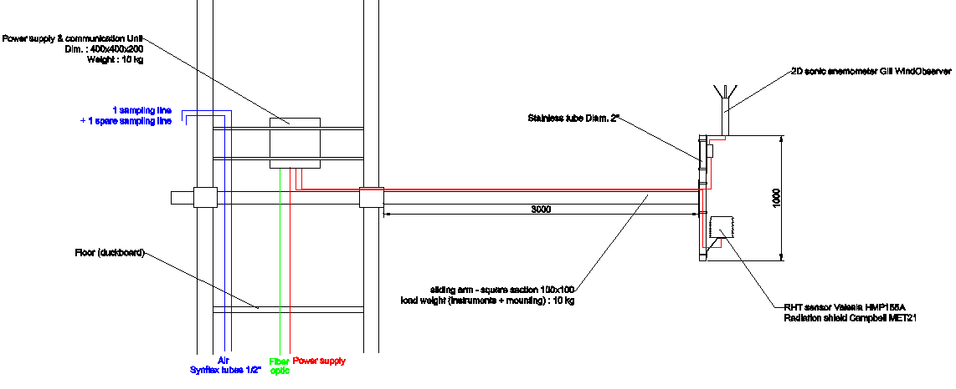

Figure 1: example of sensor installation on a tower
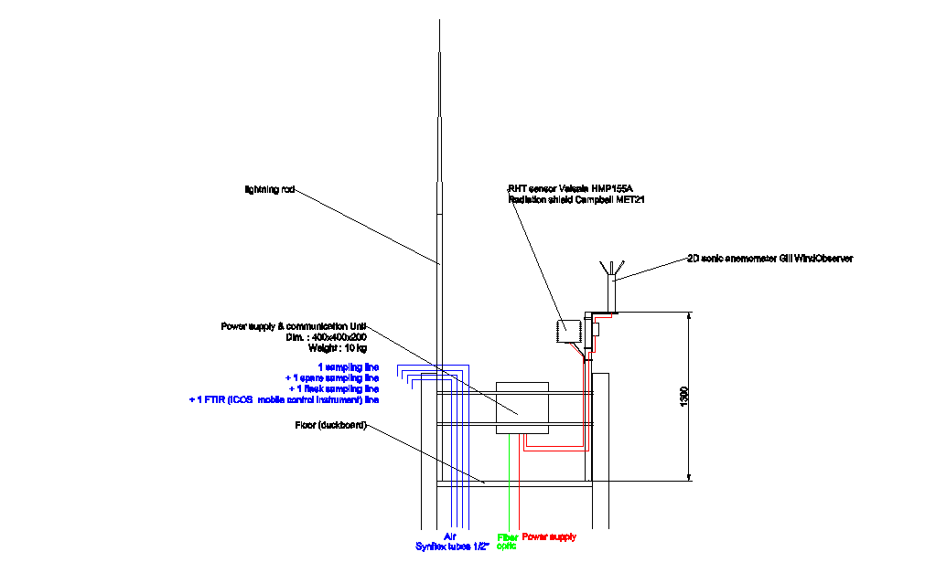

Figure 2: example of sensor installation at the tower top

    - Planetary boundary layer height retrieval instrument

The ceilometer or lidar must be collocated with the tall tower to provide suitable data to use and integrate for atmospheric modelling. However, in certain cases, the BLH can be retrieved from an external and dense ceilometers/lidar network if the network setup (instrument specs, instrument location beside ICOS AS) and its raw data management are ICOS compliant (ATC requirement in terms of data format, transfer...). The criteria for such a network acceptance will be defined within the project ICOS-INWIRE.

    - Flask sampling

The flask sampler must have its own dedicated, independent sampling line. The sampling line must consist of a 1300 Synflex tubing. The air must be sampled from the same location of the highest sampling height used for the continuous gas analysis.

    - Radiocarbon sampler

The Radiocarbon sampler must have its own dedicated sampling line. The sampling line must consist of 1300 Synflex tubing. The air must be sampled from the same location of the highest sampling height of the continuous gas analysis and the flask sampler.

    - Radon monitor

A dedicated intake line for radon is mandatory
If the ANSTO method is used (see 2.2.5), air sampling should be from the highest sampling height of continuous gas sampling. The intake line specifications will be defined at a later stage.
If UHEI-IUP method is used, sampling height should be ≤ 100m at a height with continuous gas sampling. A dedicated 1300 Synflex tubing should be used. The detector head must be installed at the bottom of the tower. The tubing from the air inlet to the detector must be as straight as possible (avoiding especially angles with small radii of curvature) to limit aerosol loss. For the same reason, any kind of filter is proscribed upstream of the detector. Thus, the air inlet consists of a simple rain guard.

    - Shelter and tower setup requirement/recommendation

A special attention should be paid to the sampling line installation to avoid the risk of stagnant water (rain, condensing) in the line. This can induce artifact on CO₂ measurement. It is recommended to avoid any “low point” (cf. Figure 3) along the sampling line. The sampling must always follow a negative slope.
In order to limit the risk of condensing in the sampling line due to the room (air conditioned)-outdoor temperature difference, it is recommended to install a cooled (around 5°C) water trap on the sampling line inside the instrumented room. This system should be installed as close as possible to the sampling line’s entry point in the room to avoid condensing upstream the water trap.
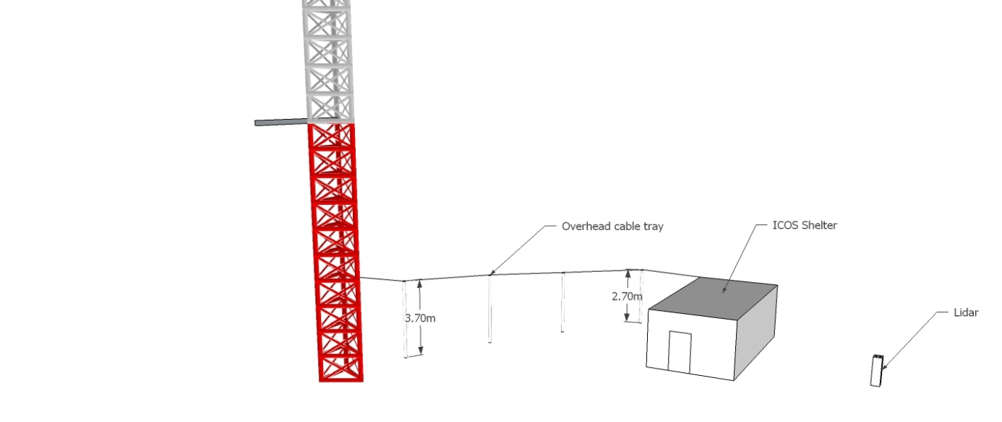

Figure 3: Example of sampling line installation

  - Air Sampling design
    - Continuous measurement

Plumbing design:
ICOS do not impose any standardized architecture but ATC listed the required/recommended/ruled out plumbing parts (first version available on the ICOS forum: https://icos-atc.lsce.ipsl.fr/forum/). A suggested Class 1 and 2 station design is provided (figure 4 and 5) by ATC to assist station design if requested.

Ambient air sampling :

Tubing:
- Recommended tubing: Synflex 1300 manufactured by EATON. If possible, in one single piece (without connector).
- Alternative to the Synflex tubing: stainless steel tubing by paying special attention to the risk of water condensing (especially with the outdoor/indoor temperature difference).
It is required to continuously flush the sampling line by using a dedicated pump for each sampling line or a shared Pump or blower.
The tubing diameter and the flushing flow rate should be selected to limit the residence time and the pressure drop (to limit the leakage risk and water condensation) as follows:
- Residence time < 1 minute
- Pressure drop < 150 mbar
For practicality, an ICOS AS not equipped with tall tower can use a ¼” Synflex tubing (<40m length) with a flushing flow rate around 5-10 SLPM.
The sampling line should be made of a minimum number of parts, especially connectors which should be used sparsely due to the potential leakage they induce. Thus, the Synflex tubing must be as possible, a single piece.
In order to protect the sampling line from water, the air inlet must be equipped with a rain guard. Using a proper filter on the inlet is currently under consideration. Laboratory and field tests for filter assessment under specific weather conditions (ice, snow, fog) are currently in progress.

Besides the dedicated sampling lines required in the section 2.3 (flask sampling, radon, radiocarbon) and the one(s) required for the continuous gas analyzers, ICOS requires at least the following additional sampling lines:
- One dedicated sampling line at the highest sampling height for the travelling instrument (see section 6).
- A spare sampling line at each sampling height for quality control purpose (cf. 6.4). These spare lines allow swapping lines when one is obstructed.

It is recommended to install a cooled (around 5°C) water trap in the sampling line when the dew point on site is often above the air conditioned room temperature (e.g. conventional fridge or peltier cooler).

Gas distribution equipment:
The required equipment is a rotary valve from Valco (model EMT2SD). The number of ports must be adapted to the station setup (number of tower sampling heights and gas cylinders).
Alternative option may be accepted after proving its suitability (dead volume, material compatibility, absence of leakages).

Monitoring of station ancillary data:
In order to assist the station’s PI for the data control and validation, ICOS requires the monitoring of the following mandatory Station Ancillary Data:
- Flushing flow rate of each tubing : mass flowmeter (see part list on the ICOS forum)
- Instrument flow rate: mass flowmeter (see part list on the ICOS forum)
- Room temperature : PT100 sensor (see part list on the ICOS forum)

The data acquisition of these sensors must be carried out by a dedicated computer with data acquisition interface (see part list available on the ICOS forum).

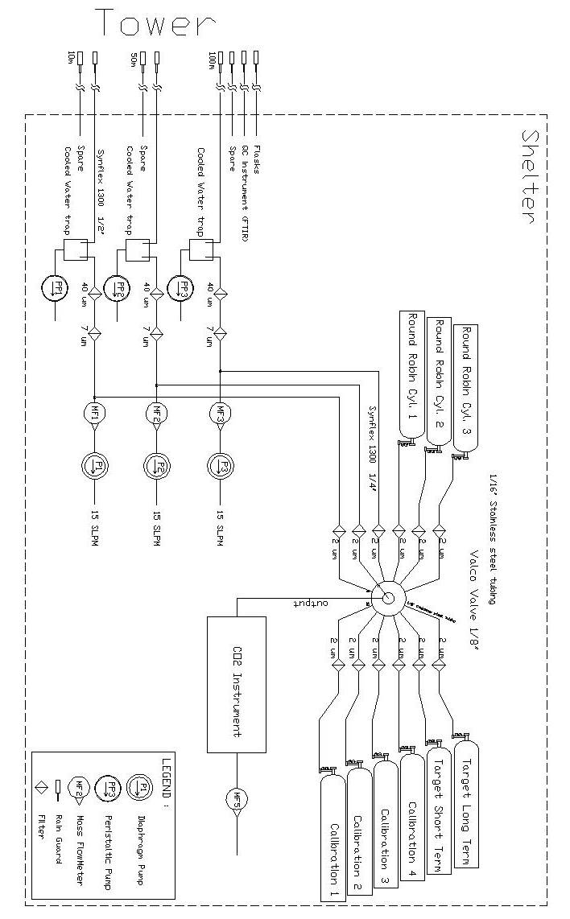
Figure 4: ICOS AS plumbing design suggestion (multi sampling height tower)

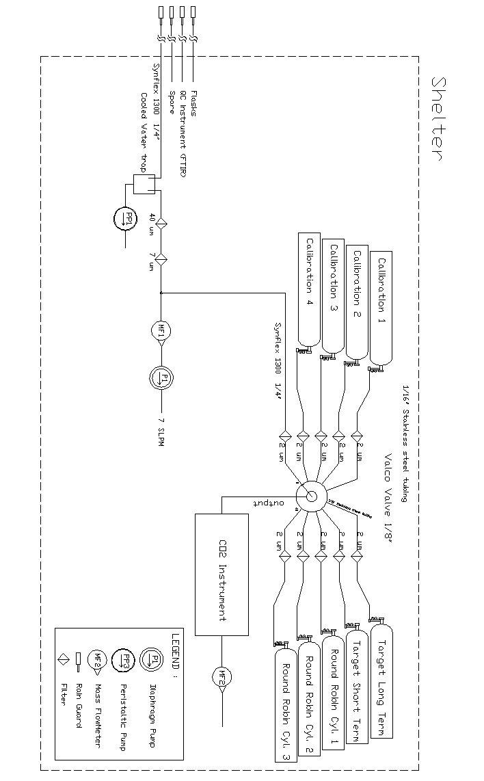
Figure 5: ICOS AS plumbing design suggestion (single sampling height)
    - Periodical sampling
Flask sampling as well as event sampling for ¹⁴CO₂ analysis should go through a buffer volume (integration ≥30 minutes). The buffer volume design will be specified at a later stage (tests in progress).

  - Maintenance

In order to reach the 80% data coverage objective (agreed upon objective made at the 5th ICOS AS workshop in Arona, October 8th-9th 2012) targeted by ICOS, it is important to perform a regular and appropriate preventive maintenance to the different instruments, sensors and part of the atmospheric stations.
- Gas analyzer:
The maintenance is instrument specific. See the manufacturer recommendation or ATC specific note on the corresponding instrument. It is recommended to perform the instrument pump maintenance regularly. For instance, the preventive maintenance of the Picarro pump consists in changing once a year the pump diaphragms.
- sampling system (cf. the annex)
- Meteorological sensors:
The meteorological sensors’ maintenance procedure and periodicity recommended by the manufacturer must be respected. At least, ICOS recommends proceeding with a basic maintenance annually. This operation consists in the cleaning of the different sensors and the corresponding integration parts (e.g. radiation shield, pressure port), the control of sensor fastening, especially the wind sensor orientation, and visual check of the installation (cable condition …). According to the WMO recommendation, the radiation shield may have to be repainted every 2 years depending on the atmospheric pollution.
- PBLH sensor: depending on the instrument.
- Radon Monitor:
For the UHEI-IUP radon monitor, the aerosol filter must be changed at least once a month (or more frequently for sites with high concentration of aerosol).

- Measurement protocol

  - Flask sampling strategy

A pair of 2 liter flasks must be simultaneously sampled once a week. The sampling period time should be adapted to the site specification. For instance, a continental station should better sample during the afternoon in the well-developed mixing layer, while a mountain station should better sample at night time or in early morning. The coastal station should not rely on a specific period time but rather regarding the wind direction.

  - Radiocarbon sampling strategy

Two-week integrated radiocarbon sampling should be made at class one stations. Further studies are underway to specify the strategy for diurnal cycle sampling.

  - Continuous gas sampling strategy

Ambient air sampling sequence on tall tower:
All sampling heights must be sampled sequentially within an hour in order to get hourly representative data for each sampling height. Among all the sampling heights, the highest is the most important (background signal suitable for modeling purpose). Therefore, in case of one sampling height is favored, it would be the uppermost height.
Sample drying:
The requirement on sample drying for continuous in-situ gas analysis is related to the ability to get a suitable field routine protocol to regularly assess the water vapor correction on analyzer working with wet ambient air.
Appropriate tests are currently in progress.
Buffer volume use:
The interest in using a buffer volume for the continuous in-situ gas analysis is currently being evaluated (pro and cons). The studies focus in particular on the interest in having high frequency data (otherwise smoothed out if buffer volume is used) for precise QC and data validation, and the “representativeness error” otherwise made on the hourly data when multi sampling heights are used without buffer (incomplete hour data set due to the multiplexing). In parallel, a buffer volume study is currently in progress to characterize different designs and determine the best use.
This buffer issue does not apply to station with a single sampling height which should not use a buffer volume.

  - Planetary boundary layer height profile strategy

The Ceilometers/Lidars will be continuously operated to provide backscatter profiles throughout day and night. Specification for data acquisition intervals and averaging times will be determined within ICOS-INWIRE project and should be adapted depending to the in situ specifications.

- Calibration, standards
  - Continuous gas analyzer
    - Calibration protocol

Calibration requirement:
- Gas tank required:
  - 3 or 4 Calibration Standards: during the Demonstration Experiment no significant difference has been detected using 3 or 4 Calibration Standard tanks. However the fourth tank maybe useful if a problem occurs with one tank. As a result, 4 tanks are highly recommended for remote sites.
  - 2 Target Gases:
    - A performance Target Gas (also called short term target gas) used for daily Quality Control (QC) and uncertainty estimation.
    - An archive Target Gas (also called long term target gas) used also for QC purposes but over the station lifelong to interlink different calibration sets.
  - Depending on the Quality management strategy, additional QC gases may be required or recommended (dedicated gas for intake system test…).
All calibration and target gases have to be prepared (e.g. tank filling) and calibrated by the ICOS CAL. The cylinders are owned by the stations.
The cylinders should be replaced once the cylinder pressure has decreased to 30 bar in order to allow the CAL performing a last cylinder calibration before their pressure reach the critical value estimated at 20 bar by the WMO (cf. GAW report N°206). Cylinder replacement must be initiated by the station PI who must contact the CAL with 3 month anticipation. Given this anticipation need and the frequent use of the short term target, it is highly recommended to have a spare one onsite.

- An initial test period is highly recommended when setting up a new station in order to define the best calibration strategy adapted to the station setup: injection duration (depending on the stabilization time in relation with the flow rate and the dead volumes), calibration frequency and number of calibration cycles. The test period must last at least 3 months to get a sufficient amount of data for a detailed analysis. The initial test consists in using a stringent calibration strategy.
For CRDS (Cavity Ring-Down Spectroscopy) instrumentation, the initial test calibration setup should be as follows:
  - Gas injection duration: 30 minutes
  - Number of cycles (tank analysis) during a calibration : 4
  - Calibration frequency: every 15 days
  - Performance target frequency: every 12 hours

Depending on the initial test results, the calibration strategy must be then adjusted (with ATC support). However the calibration must respect the minimum ICOS calibration requirement (cf. Table 11).

 | Min.  number | Min.  frequency | Min. gas injection duration |  | Min. calibration cycle number |  | Range | Expected lifetime  (40L tanks)
Calibration Standard | 3 | 1 month* | 15 minutes or site specific* | 2* |  | Span the unpolluted atmospheric range |  | > 10 years
Performance Target gas | 1 | 24 hr* | 15 minutes or site specific* | - |  | Low concentration |  | > 1.5 years
Archive  Target gas | 1 | 15 days | 15 minutes or site specific* | - |  | High concentration |  | > 20 years
 |  |  | *can be higher depending to the initial site test results
Table 11: Minimum ICOS requirements for the calibration of an ICOS CRDS analyzer

In order to assist station PI in the calibration optimization, the ATC provides:
- systematic comparison of linear/quadratic fits should be implemented
- data products for calibration optimization
It should be noted the ICOS processing chain applies a linear interpolation to the data in between two calibrations in order to refine the calibration coefficients.

For quality control and performance estimate purpose the continuous gas analyzers measure regularly 2 types of target gas: a performance target gas and an archive target gas. See the corresponding sections 6.4 and 6.5 for detailed information.

    - Calibration equipment

The CAL is in charge of tank filling and analysis. Calibration and target gas containers (tanks) are not provided by the CAL and must be bought by station owners according to the CAL/ATC’s requirements.
The current ICOS tank setup (tank + valve) meeting the aforementioned CAL/ATC requirements is:
- Cylinder: 6061 Aluminum cylinder manufactured by Luxfer UK (π-certified):
- Cylinder valve: Rotarex membrane valve (D200 type with PCTFE seat). Body material : brass or stainless steel
- Pressure regulator fitting: DIN 14 by preference, CGA 590 also possible (CGA 580 less favored)
- Cylinder volume : 40L or 50L recommended (other volumes accepted if argued)

It is required to buy the prepared ICOS tanks (with valve installed) from one of the following currently approved suppliers:
- MATAR (Italy)
- Deuste Steininger (Germany)

This list will be updated by ATC/CAL if necessary (on its own initiative or PI submittal).

Required pressure regulator: two models are accepted
- SCOTT MODEL 14 M-14C (or -14B) Nickel-plated brass.
- TESCOM Serie 64-3400 Stainless steel electropolish with Teflon PCTFE valve seat. Use of Stainless steel High purity gas pressure gauge (e.g. Bourdon Haenni UPG2).

Any other setup/part must be approved by ATC with appropriate compliance test.
At the station, it is highly recommended to install the cylinders and associated pressure regulator in an air temperature controlled room to avoid potential bias induced by temperature variation. Moreover, it is recommended to install the tank and pressure regulator in a dedicated enclosed rack to buffer temperature change potentially induced by the air conditioning air flow. The ideal cylinder position within the rack is laid down in order to limit the stratification and fractionation effect.
The cylinder pressure regulator must be adjusted in order to keep below 0.5 bar the difference of pressure at the instrument inlet during cylinder measurement and ambient air measurement.

    - Standard production and calibration
The Flask and Calibration Laboratory (FCL) entity of the Central Analytical Laboratory (CAL) prepares standard air mixtures for the set of ICOS parameters for continuous monitoring. The air mixture produced is made of real natural air. For calibration of field instruments, the air mixture has to cover the full range of atmospheric mixing ratios that can be expected at a monitoring site considering diurnal, seasonal, inter-annual variability and the currently observed long-term trends.
The FCL manages the high-pressure cylinder preparation, which consists in testing and conditioning of high-pressure cylinders before the filling and a dew-point control. High pressure cylinders so prepared are then calibrated by the FCL prior to shipment to the atmospheric stations.
The atmospheric stations must provide their own high pressure cylinders equipped with the accepted valve and connector types (see 4.1.2) and with valid pressure test certificate.
According to the WMO recommendations a recalibration schedule for the ICOS monitoring stations of every third year is assumed. It is intended to provide stations with a replacement set of standards for this period of recalibration to be returned by the station immediately after receipt of their proper calibration standard suite. The respective additional high pressure cylinders are owned by the CAL.
Part of the QC strategy will also be a re-analysis of the long-term target gas at the stations (again every third year, with 18 month time lag to the re-calibration of the calibration standards).

  - Other instruments

    - Meteorological sensors
The sensors should be calibrated according to the periodicity specified in the Table 12 or the manufacturer recommendation if more stringent and justified. The traceable calibration must be carried out by the manufacturer or a certified laboratory.

Sensor | Calibration periodicity (month)
Wind sensor
Ultrasonic | none
w/ moving parts (propeller or cup) | 24
Temperature sensor | 12
Relative humidity sensor | 12
Barometric pressure sensor | 24
Table 12: Recommended meteorological sensor calibration periodicity

    - Radon monitor
The UHEI-type monitor detector shall be checked every 6 months with a ²⁴¹Am α-source.

    - Planetary boundary layer height retrieval instrument
Retrieval of mixing heights from backscatter profiles provided by Ceilometers/Lidars does not strongly depend on calibration of the system. Therefore no regular calibration is foreseen. Further details will be within a task of ICOS-INWIRE project.

    - Eddy flux instrument

Refer to the ETC specification regarding the calibration of Eddy flux instruments.

  - Central Analytical Laboratory services

The Central Analytical Laboratory (CAL) is divided in 2 entities, the Flask and Calibration Laboratory (cf. 4.1.3) and the Central Radiocarbon Laboratory (CRL). It provides the following services to the atmospheric network:
- provision of calibrated standard gases in high-pressure cylinders (FCL)
- analysis of ICOS parameters (cf. Table 2) from periodical sampling (FCL and CRL)
- supply of samplers for integrated ¹⁴CO₂ analysis (CRL)

Flask air sample analysis at the FCL
The FCL analyzes air samples in flasks collected by the ICOS network for additional periodical analysis of the species (cf. Table 2) and for Quality Control purpose. The flasks are owned by each station. Once analyzed, The FCL checks every flask before sending them back to the stations to avoid sample loss. Potential error sources include leaking valves and humidity in the flask. Defective valve seals will be replaced; broken flasks will be disposed after notification of the flask owners. A sufficient number of flasks are needed to assure a constant supply for the sampling program.
Sampling details for flask air samples have to be transmitted to an FTP server by the stations at latest when a complete batch of flasks is shipped to the FCL. Such shipments should be announced by the station PIs through a web front-end of the CAL database. This database will document all steps of the flask handling including sample collection, the individual measurement steps within the CAL, flask checks and shipments. This will allow for tracking the processing status of any flask.
The flask sample analysis results are sent to the ATC server to be processed (QC task) and stored in the ATC database.

Radiocarbon sample analysis at the CRL
The CRL analyzes the radiocarbon samples collected by the class one stations in the ICOS network. Two different sampling strategies are foreseen: integrated sampling (two-weekly) and diurnal or event based sampling of individual grab samples.

Integrated samples:
The CRL will build the samplers for the integrated radiocarbon sampling and provide them to class one stations at cost price. Two different sampler types are foreseen. The current standard sampler is the robust and field proofed chemical absorption sampler using NaOH solution (cf. 2.2.5). Alternatively two different integrated whole air samplers are currently tested at the CRL and in the field. These integrated whole air samples can only be analyzed using AMS which is currently associated with higher costs. Both integrated whole air samplers need sample containers, either 3L glass flasks (cf 2.2.5) or small aluminum cylinders which need to be supplied by the station. A sufficient number of flasks/cylinders are needed to assure a constant supply for the sampling program. All whole air samples are first analyzed at the FCL for trace gases and stable isotopes. After analysis at the CRL the flasks are returned to the FCL to be conditioned and leak tested before they are shipped back to the station.

Individual samples:
Diurnal and event based radiocarbon flask sampling is foreseen to be performed using the ICOS flask sampler (cf 2.2.4). Using the 3L glass flasks (cf 2.2.5) is required. All diurnal or event based radiocarbon samples are first analyzed at the FCL for trace gases and stable isotopes. After analysis at the CRL the flasks are returned to the FCL to be conditioned and leak tested before they are shipped back to the station.

The radiocarbon sample analysis results are sent to the ATC server via the CAL database to be stored in the ATC database.
- Data management

  - Overview

Daily datasets sent to the ATC will be automatically processed and stored in the ATC database. The processing can be simple or multi-step depending on the type of instrument (e.g. the Picarro data get corrected whereas there is no correction currently applied on meteorological data).
In all cases, the processing is flexible and all the processing steps are traced and the maximum of metadata is associated to the data. To do so, the system needs two types of information: metadata and processing parameterization which must be provided by the station PIs.
It is absolutely necessary to keep the information up to date. This is the responsibility of the station PI to keep the ATC database updated with all the modifications/interventions occurred at the station. For instance, if an instrument breaks down and is replaced by another one of the same model, or when an instrument is moved around, the database must be updated. Similarly target or calibration tank changes must be registered as well as any change in the air intake system or the measurement protocol.
The details of the information to provide, the data format and transfer procedure in order to send data to the ATC are described in detail in the document “ProvidingDataToATC” available on the ATC website (https://icos-atc.lsce.ipsl.fr).
Prior to starting to send the data once a day, the station PI must:
- Open a SFTP account (associated to the station) on the ATC server in order to allow the data transfer to ATC. Require to fill and sign a form available on the ATC website.
- Open a SSH account (associated to a person) to access to the ATC tools for data mining, data flagging and configuration modification. Same requirements than for SFTP (unique form).
- Register the station and its instrument with the appropriate form available on the ATC website.

  - Metadata

Here we define metadata as the "information related data content”. This information will allow the end users to know from where the data are coming from and how they have been obtained.
Metadata must be fed by the station PI into the system through the ATC configuration application call ATCConfig.
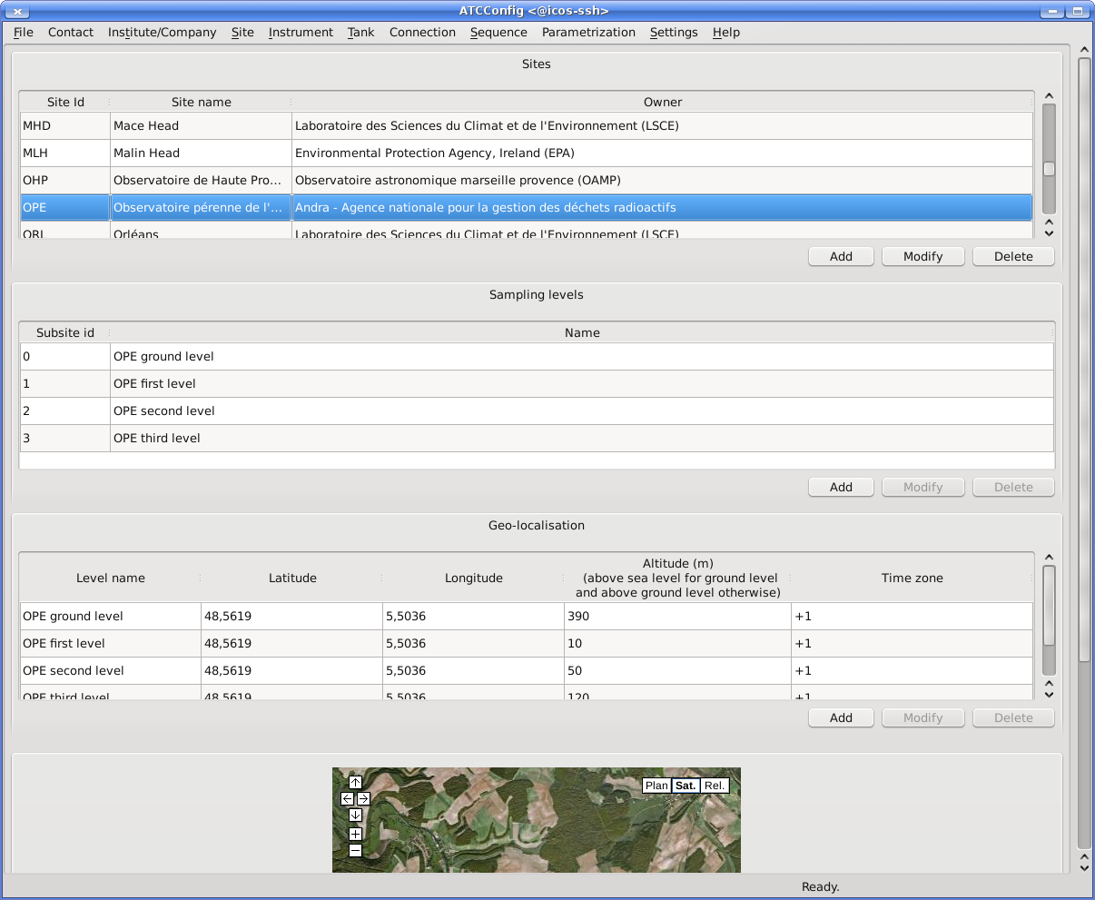
Figure 6: ATCConfig software (screen capture)
The categories of metadata to provide are:
- institute/laboratory
- station general information
- instrument
- tank
- flask

  - Data processing and archiving

The processing chains are flexible and need to be configured. Configuration is specified for each instrument and site as an instrument can be moved from one station to another. Most of the information is managed by the ATCConfig application.
All the data timestamps (beginning of the time interval if averaging) must be given in UTC since the ATC database assumes so and do not perform checks on this. Moreover all configuration information must also be given in UTC.
There is a processing chain per instrument type, this implies that the requested information, parameterization and file format, is also defined by instrument type.
All the data files sent to the ATC are archived. For some instruments, like the Cavity Ring Down Spectrometer from Picarro Inc., only a subset of the data are processed by the ATC (the complete list of variables or the spectrum files are not processed), but the full data files should also be provided by station’s PIs to the ATC for archiving. Considering the size of such files, they will not be sent by sftp but more likely provided by other means like a 6 month or annual CD or a USB key sent by post mail.

  - Additional station metadata and station ancillary data

It has been suggested that some additional ancillary data and metadata from the station would be helpful to better understand and qualify the measured trace gas data.
Discussions about information to provide and its frequency are still ongoing.
Mandatory Station Ancillary Data:
- Flushing flow rate for each sampling line used for continuous gas analysis
- Instrument flow rate
- Room temperature

Mandatory Station Metadata:
- Sampling, conditioning and distribution system diagram with part reference
- Buffer volume use (Yes/No)
- Drying system use (Yes/No)
- Sample pressurization pump use (Yes/No)
- Tank pressure (monthly manually monitored value)

  - Data quality control

The ATC provides an application called ATCQc to allow PIs to manually qualify/flag their data. This is an important and mandatory step in ICOS. Data can be qualified/flagged at any aggregation level (raw, minute, or hour/injection). Data qualification/flagging applies to gas analyzers data (ambient or tank data), radon and meteorological data.
Using a secured encrypted connection to ATC data server, PIs have direct access through ATCQc to their data and can manually reject invalid/contaminated/outlier measurements.
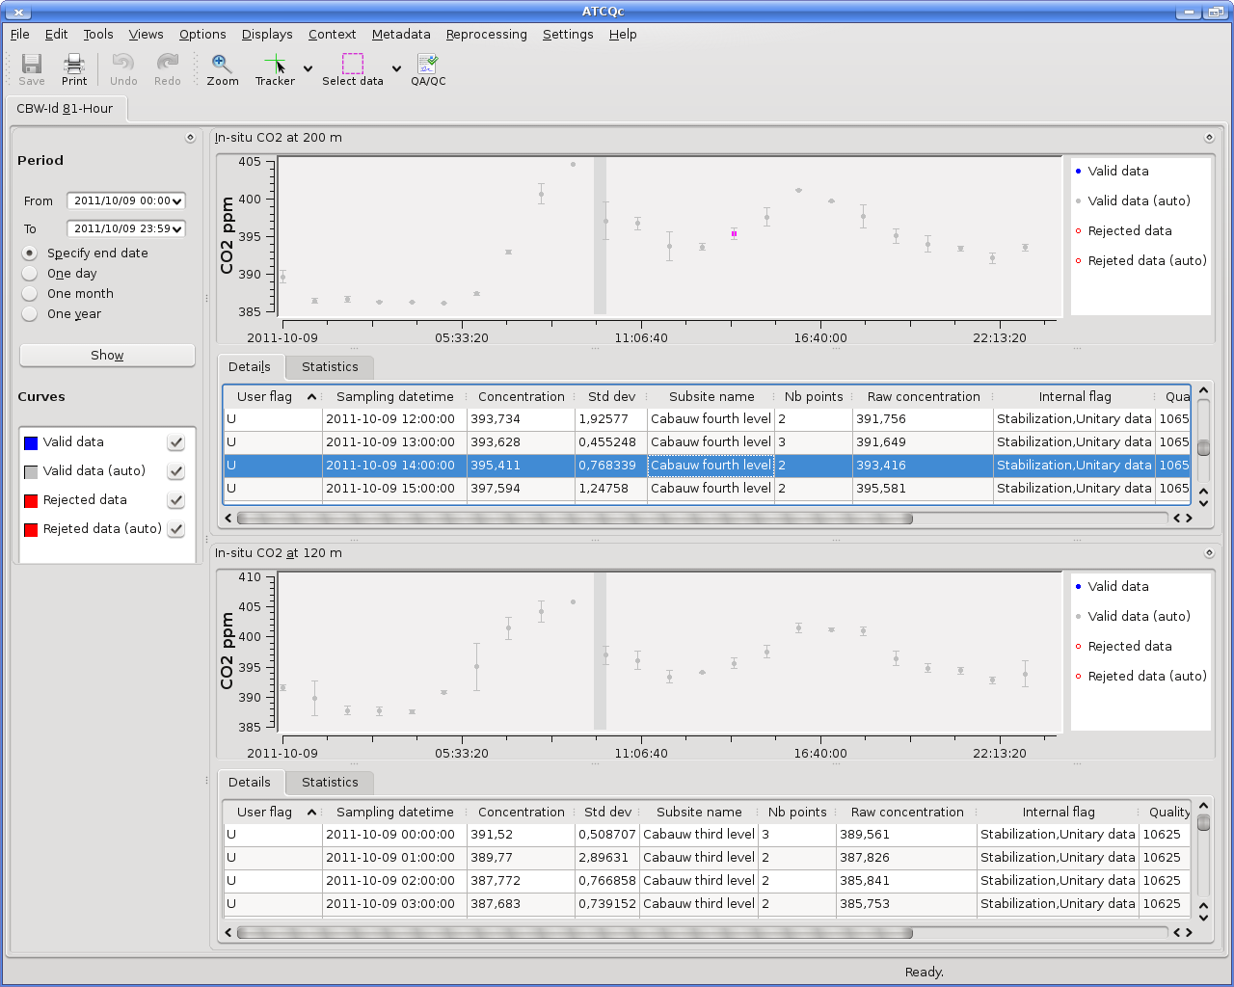
Figure 7 : ATCQc software (screen capture)
As an help to the PIs, available instrument ancillary data and station ancillary data can be displayed.
In addition to ATCQc, ATC offers a bundle of graphical data products freely available online to allow PIs to qualify and monitor their instrument. Those plots are daily generated, for each station.
A web application developed by ATC allows to discover all these ICOS instrumental products online (https://icos-atc.lsce.ipsl.fr/icos-data-products).

#id | Family | Description | Product Example
0000 | Metadata | - P0000.1 Instrument installed on the network  - P0000.2 Calibration gas concentration | 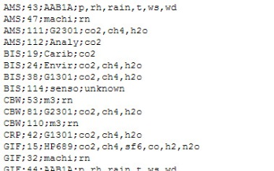
0001 | Tracking accuracy of an instrument | - P0001.1 Precision instrument in ICOS Network  - P0001.2 Time series of minute SD  - P0001.3 Table of instrument precision  - P0001.4 Time series of minute SD | 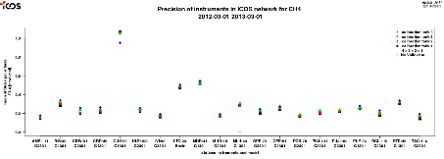
0002 | Calibration monitoring | - P0002.1 Result of calibration per calibration cycle  - P0002.2 Calibration tank drift  - P0002.3 Residue evolution  - P0002.6 Evolution of the calibration equation  - P0002.7 Linear and default fit residual comparison | 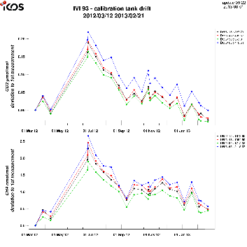
0003 | Target gas monitoring | - P0003.1 target gas evolution in time  - P0003.2 Instrumental drift | 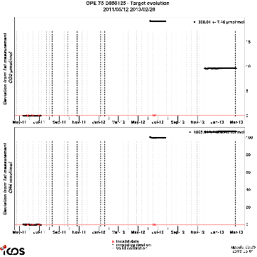
0004 | Air monitoring | - P0004.1 Last year snapshot  - P0004.2 last month snapshot  - P0004.3 last week snapshot  - P0004.4 last 3 days snapshot  - P0004.5 valid data snapshot  - P0004.6 Data validation advancement | 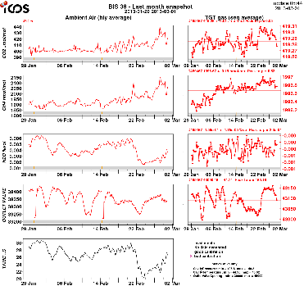
0006 | Comparisons instruments/instruments | - P0006.1 comparison of instruments on the same site over a year  - P0006.2 comparison of instruments on the same site over a month | 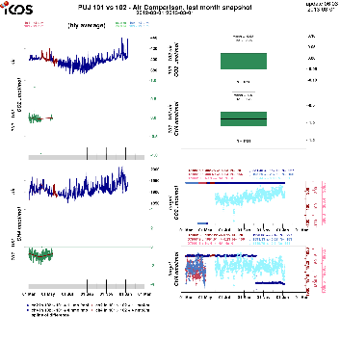
0008 | Value-added products | - P0008.1 Data selection sector (Ocean or continent) | 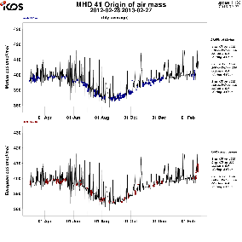
0009 | Meteo | - P0009.1 Last year meteorological data  - P0009.2 Last month meteorological data  - P0009.3 Last week meteorological data  - P0009.4 Last 3 days meteorological data | 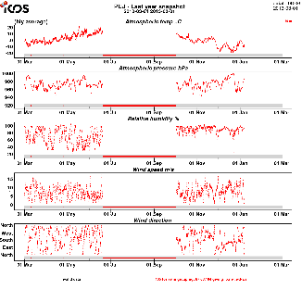
Table 13: Data products provided by ATC

Synthetic information is summarized and can quickly be accessed through a “panel board”, specific to each station (see https://icos-atc.lsce.ipsl.fr/demo-experiment-network , and click a station), and NRT time series of CO₂ and CH₄ can be browsed on last two months, using the “interactive plot” tool. All data product are daily refreshed to take into consideration some possible recent modifications made by PIs on measurement, through ATCQc, for example.

  - Data revision
The data revision is ensured by the ATC when a primary calibration scale is changed.

- Quality management
High, proven quality is a requirement for the ICOS data to be useful. ICOS has adopted compatibility targets of the Global Atmosphere Watch (GAW) program of the World Meteorological Organization (WMO). To achieve these targets ICOS implements a quality management plan, which defines quality assurance and quality control measures. Credibility of the ICOS data depends critically on the performance of transparent quality control. In this chapter, we first give an overview of quality management and then list quality control actions.
  - Quality management overview
The definitions of quality assurance (QA) and quality control (QC) as given in the GAW report No. 185 are quite general:
- Quality Control: operational techniques and activities that are used to maintain and verify given requirements for quality.
- Quality Assurance: all planned and systematic actions necessary to provide adequate confidence that a product, process or service will satisfy given requirements for quality

From these definitions the major differences between QC and QA are summarized in Table 14 along with some examples for their applicants for trace gas measurements.
 | QC | QA
Orientation | Product | Process
Time horizon | Reactive | Pro active
Usage | find problems | prevent problem
Focus | Data accuracy | How to properly design and perform a measurement process
Examples for an atmospheric ICOS station
 | Target measurements | Measurement guide lines
 | Co-located flask measurement | Staff training
 | Use flows, cooler temperatures and pressures for initial data flagging. | Monitoring flows, cryo cooler temperature, changing valves, etc.
 | Inter-comparison activities, travelling instrument | Regular calibration,  leak detection

Table 14: Summary of QC and QA differences along with examples for GHG measurements

In addition to QC and QA, quality audit is another quality management term defined as « the process of systematic examination of a quality system (QA and QC) carried out by an internal or external quality auditor or an audit team. Quality audits are typically performed at predefined time intervals and ensure that the institution has clearly defined internal system monitoring procedures linked to effective action. This can help determine if the organization complies with the defined quality system processes and can involve procedural or results-based assessment criteria ».

  - Quality management system targeted for the ICOS atmospheric network
    - Quality assurance
In ICOS, the initial validation of the station, the use of common, pre-tested instruments, standardized measurement systems, trained personnel, centralized production of calibration and target gases together with common data processing including on-line quality checking and warnings creates good grounds for data quality assurance and high compatibility of the measurements.
Quality assurance is directly linked to good laboratory praxis and the ICOS measurement guide lines mentioned in the present document. It will be completed by the WMO CO₂ measurement guide lines currently worked out by Manning A. and Crotwell A. It is mandatory for each station to have a printed version of the measurement guidelines in the station which will serve as a reference book for bench work. At those stations where the personnel is not very fluent in English, the Station PI should prepare a translated version of the guidelines. The measurement guidelines should also cover a detailed maintenance schedule for the wearing parts of the station and for performing leak tests. The ATC is encouraged to include a detailed maintenance section in the electronic station logbook and send reminders to the station PIs.
Another aspect of the QA deals with the training of personnel. The ATC will offer training capacity for ICOS station personnel. We recommend a mandatory training session for all ICOS station personnel, even if the respective personnel is already experienced in trace gas measurement. This will help unifying the measurement and quality control process within the ICOS network. The scope of the ATC training session should be adapted to the pre-knowledge of the participants.

    - Quality control
Quality control is the verification of the fulfilling of the data quality objectives for each ICOS atmospheric station. It thus provides important information on the performance of the station as well as on the network compatibility internally and with other sources of observations. The ICOS atmospheric station network QC is split into three different hierarchies: station internal QC, ICOS internal QC and ICOS external QC. These different levels of QC assure compatibility and credibility of the data.

Station internal QC: All QC actions/measurements performed at a station, without referencing to any station external body (e.g. repeatability checks, target measurements, line tests, etc.).
Aims: Assuring that the station performance meets the data quality objectives (DQOs)

ICOS internal QC: All QC actions/measurements performed at a station, referencing to an ICOS central facility that supervises data quality objectives (e.g. flask vs. continuous comparison, Round/Star-Robins, travelling instrument, etc. with the ICOS CAL).
Aims: External verification of station performance including (parts of the) data processing, assuring network compatibility.

ICOS external QC: All QC action/measurements performed at a station, referencing to an ICOS external body. (e.g. WMO-Round Robins)
Aims: Generate credibility for the ICOS data, by having a completely independent validation outside the ICOS framework.

    - Quality audit
ICOS targets two different hierarchies of quality audits: internal and external quality audits.
The internal quality audits will be carried out by auditors from an ICOS central facility. Internal audits shall check and verify the stations compliance to the ICOS measurement guidelines and the quality control procedures.

The external quality audits have to be performed by an external body and will focus on the validation of the entire ICOS quality management system and its implementation. We propose to have these external quality audits every five years, ideally performed by an audit team from a non-European organization with distinguished experience in atmospheric trace gas monitoring networks.

  - Requirements for a comprehensive quality control strategy
The requirements for a comprehensive quality control system of an atmospheric GHG network are complex. Thus, multiple tools will be needed to cover the various aspects. In the following, the key points which have to be addressed by such a comprehensive quality control system are listed:
- Precision: The precision of the applied quality control measure defines the needed statistics to detect differences on the order of the data quality objectives (DQOs). Preferably the precision of an applied QC measure should be at least twice the requested DQOs precision.
- Frequency: Comparison frequency must allow to quickly detecting potential problems.
- Comprehensiveness: It must describe which parts of the analytical set-up are tested and should preferably test all parts of the measurement system.
- Concentration range coverage: It should be suitable for the considered station and slightly exceed the stations ambient concentration range.
- External station validation: This quality control item is mandatory to create credibility of the network data.

Table 15 summarizes quality control approach that could be applied at field stations and classifies them according to the previously defined quality characteristics. Each QC technique mentioned has its own strengths and weaknesses.
 | Precision | Frequency | Comprehensive ness | Conc. Range | External validation
Target gases | High | Sub-daily | No | Limited | Limited
Flask vs. in-situ | Low | Weekly | Full | Entire | Yes
Cylinder RR* | High | 1-2 per year | No | Limited | Yes
Travelling instrument | High | occasional | Full (ability to pinpoint individual problems) | Entire | Yes
Table 15: Classification of existing quality control approaches according to the pre-defined quality characteristics. Cylinder RR* (Round Robin) is a circulating gas cylinder whose concentration is not known by AS personnel. Analysis result at each station is used for testing the performance of the station.

  - Quality control strategy for the ICOS atmospheric network
The QM strategy as proposed below does fulfill all needs in terms of precision, frequency, concentration range coverage, external validation as well as comprehensiveness. The diversity of the applied QC measures complements one another and offers sufficient redundancies to act as a defensible QM system.
For Quality Control of ICOS atmospheric measurements, the targeted duties are:
1) Entire check of proper functioning of the instrumentation (including instrumental validation and qualification phase at ATC Metrological Lab) and the intake system before a station becomes operational. AS PI must prepare a full description of the measurement system and protocols, which will be checked by ATC (check list provided by the ATC). ATC is currently studying the feasibility of an initial onsite station audit.
2) High frequency instrument target gas (also called “Performance target gas”) measurements at the station to be able to quickly detect malfunctioning of the instrument, insertion point: selection valve. Concentration ranges for all species at the expected low end of the concentration range (background conditions) for the particular station.
3) Low frequency instrument target gas (also called “Archive target gas”) measurements to be able to quantify system stability over decades, insertion point: selection valve. Concentration ranges for all species above the expected high end of the concentration range for the particular station.
4) Measurement systems, which have devices such as a sampling pump, drier, buffer volumes, in the inlet line upstream of the analyzer, has to be tested by a target gas measurement, which has an insertion point upstream of these devices. The test conditions (e.g. sample flow rate and pressure) have to be comparable to the conditions for the ambient sampling. The same target gas has to be measured at the selection valve insertion point as well. This test has to be done during maintenance visits at least twice per year. The concentrations of this target should be close to background conditions for the respective station.
5) Regular (on at least weekly basis is highly recommended) data inspection (including calibration and target gas measurements) by stations PIs using ATC Data Products and the ATCQc tool and participation in the Monitoring Station Assembly.
6) Yearly intake system test, testing the entire sample intake line (all heights). Intake system test may be done by inserting gas of known concentration to the inlet, or comparing ambient air concentrations swapping between sample inlet and spare line (ideally simultaneously with 2 instruments or in very stable ambient conditions if only one instrument available) or as a leak test.
7) Regular flask – in-situ measurement comparison for Class 1 stations on a weekly basis from the highest sampling height.
8) Travelling cylinders (so-called Round Robins), which are high-pressure cylinders whose concentrations are unknown for the AS PI, to externally check the instruments and the calibration scales (these should be calibrated by WMO-CCL). This should be carried out as a blind test every 2 years. Funding has to be sought for this exercise.
9) In case of problems at a Class 2 station, a mobile flask sampler is shipped to the station to perform parallel measurements.
10) The ATC Mobile Lab serving as a diagnostic tool particularly for stations where systematic biases in the flask vs. in-situ comparison occur. During a Mobile Lab visit a system and performance audit will be conducted.
Not mandatory, but highly recommended task is to measure blank (e.g. synthetic air or N₂ grade: 5.0) and laboratory air on a weekly basis.

  - Measurement uncertainties

The measurement uncertainties will be estimated by ATC using performance target gas measurement and error estimate studies (e.g. error on water vapor correction, on representativeness of the hourly average data for multi sampling height sites). The detailed computation of this uncertainty is still to be implemented and is also currently studied in the framework of the InGOS project.
- Outlook

The present document describes the current state of the ICOS requirements and recommendations for the atmospheric stations. Several topics such as PBLH measurement and automated flask sampling require additional work to define the corresponding requirements and recommendations. This work is currently in progress mainly in the framework of the ICOS-INWIRE project.
The next release of this document will present the results of the ongoing work and the update of the actual specifications described here.
- References
  - Abbreviations and acronyms

ACTRIS - Aerosols, Clouds, and Trace gases Research InfraStructure Network
AGAGE - Advanced Global Atmospheric Gases Experiment
ANSTO - Australian Nuclear Science and Technology Organisation
AS - Atmospheric Station

ATC - Atmospheric Thematic Center

BLH - Boundary Layer Height
CAL - Central Analytical Laboratory
CRDS – Cavity Ring Down Spectrometer
ETC - Ecosystem Thematic Center
ERIC - European Research Infrastructure Consortium
FTIR – Fourier Transform Infrared
GAW - Global Atmosphere Watch (WMO programme)
ICOS - Integrated Carbon Observing System
ICOS-INWIRE - ICOS Improved sensors, NetWork and Interoperability for GMES
InGOS - Integrated non-CO₂ Greenhouse gas Observing System
MPI - Max Planck Institute (Germany)
MSA - Monitoring Station Assembly
NOAA - National Oceanic and Atmospheric Administration (USA)
OTC - Oceanic Thematic Center
PBLH - Planetary Boundary Layer Height
PI - Principal Investigator
PPB - Parts Per Billion (see definition chap 8.2)
PPM - Parts Per Million (see definition chap 8.2)
PPT - Parts Per Trillion (see definition chap 8.2)
QA - Quality Assurance
QC - Quality Control
UHEI - University of Heidelberg (Germany)
VIM - International Vocabulary of Metrology
VPDB - Vienna Pee Dee Belemnite (Isotope Standard)
VSMOW - Vienna Standard Mean Ocean Water (Isotope Standard)

  - Terms and definitions

Calibration cylinder (also referred to as Calibration gas or Calibration standard):
Cylinder containing natural dry air or a synthetic gas mixture with assigned trace gas mole fractions that is used routinely to calibrate the gas analyzer on site. In ICOS, the calibration cylinders are prepared with natural dry air and calibrated (mole fraction assignment) against a NOAA scale by the ICOS CAL.

Gas concentration unit (used in this document):
Mole fractions of substances in dry air (dry air includes all gaseous species except water)
ppm = μmol/mol =10⁻⁶ mole of trace substance per mole of dry air
ppb = nmol/mol =10⁻⁹ mole of trace substance per mole of dry air
ppt = pmol/mol =10⁻¹² mole of trace substance per mole of dry air

Quality assurance:
All planned and systematic actions necessary to provide adequate confidence that a product, process or service will satisfy given requirements for quality.

Quality control:
Operational techniques and activities that are used to maintain and verify given requirements for quality.

Target cylinder (also referred to as Target gas).
Cylinder containing natural dry air or a synthetic gas mixture with assigned trace gas mole fractions that is treated routinely as an (unknown) sample in a sequence of analyses. In ICOS, the target cylinders are prepared with natural dry air by the ATC. They are used for quality control measures.

  - Bibliography

List of the documents referenced in the present document:

World Meteorological Organization, Guide to meteorological instruments and methods of observation. WMO N°8, 7th edition, 2008.

World Meteorological Organization, Guidelines for the Measurement of Methane and Nitrous Oxide and their Quality Assurance. GAW report N° 185, WMO/TD-No. 1478, 2009.

World Meteorological Organization, Guidelines for the Measurement of Atmospheric Carbon Monoxide. GAW report N° 192, WMO/TD-N° 1551, 2010

World Meteorological Organization, Strategy for the Implementation of the Global Atmosphere Watch Programme(2001 - 2007), GAW Report N° 142, 2001

World Meteorological Organization, 15th WMO/IAEA Meeting of Experts on Carbon Dioxide, Other Greenhouse Gases and Related Tracers Measurement Techniques. GAW report N° 194, WMO/TD –No 1553, 2011.

World Meteorological Organization, 16th WMO/IAEA Meeting of Experts on Carbon Dioxide, Other Greenhouse Gases and Related Tracers Measurement Techniques. GAW report N° 206, 2012.

VIM, International vocabulary of metrology – Basic and general concepts and associated terms (VIM). 3rd edition, Joint Committee for Guides in Metrology (JCGM), JCGM 200:2012

Haeffelin et al., Evaluation of Mixing-Height Retrievals from Automatic Profiling Lidars and Ceilometers in View of Future Integrated Networks in Europe. Boundary-Layer Meteorology, pp. 1–27, 2011

Milroy et al., On the ability of pseudo-operational ground-based light detection and ranging (LIDAR) sensors to determine boundary-layer structure: intercomparison and comparison with in-situ radiosounding, Atmos. Meas. Tech. Discuss., 4, 563-597, 2011

Hammer et al., Feasibility study of using a "travelling" CO₂ and CH₄ instrument to validate continuous in situ measurement stations. Atmos. Meas. Tech., 6, 1201–1216, 2013

  - List of contributors

The persons listed below have actively contributed to the writing and reviewing process of the present document:

Baum, S. (MPI, Germany)
Delmotte, M. (LSCE, France)
Dvorska, A. (CzechGlobe, Czech. Rep.)
Gerbig, C. (MPI, Germany)
Gomez-Pelaez, A. (AEMET, Spain)
Grant, A. (University of Bristol, England)
Hammer, S. (UHEI, Germany)
Hanus, V. (CzechGlobe, Czech. Rep.)
Hazan, L. (LSCE, France)
Jordan, A. (MPI, Germany)
Laurent, O. (LSCE, France)
Laurila, T. (FMI, Finland)
Lavric, J. (MPI, Germany)
Levin, I. (UHEI, Germany)
Lindroth, A. (Lund University, Sweeden)
Manning, A. (UEA, England)
Morgui, J. A. (IC3, Spain)
O’Doherty, S. (University of Bristol, England)
Paris, J. D. (LSCE, France)
Pavelka, M. (CzechGlobe, Czech. Rep.)
Pilegaard, K. (DTU, Denmark)
Plass-Duelmer, C. (DWD, Germany)
Ramonet, M. (LSCE, France)
Reiter, I. (OAMP, France)
Rivier, L. (LSCE, France)
Schmidt, M. (LSCE, France)
Steinbacher, M. (EMPA, Switzerland)
Tarniewicz, J. (LSCE, France)
Vermeulen, A. (ECN, Netherlands)
Wastine, B. (LSCE, France)

Acknowledgments:
ICOS atmospheric workshop attendees and especially those involved in the ICOS working groups are gratefully acknowledged for their contribution.

